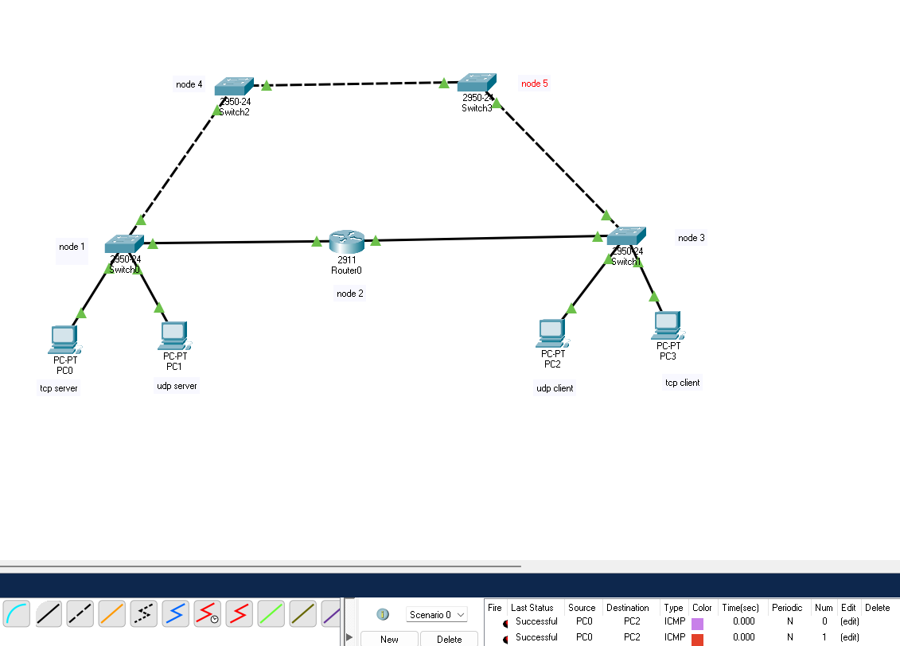

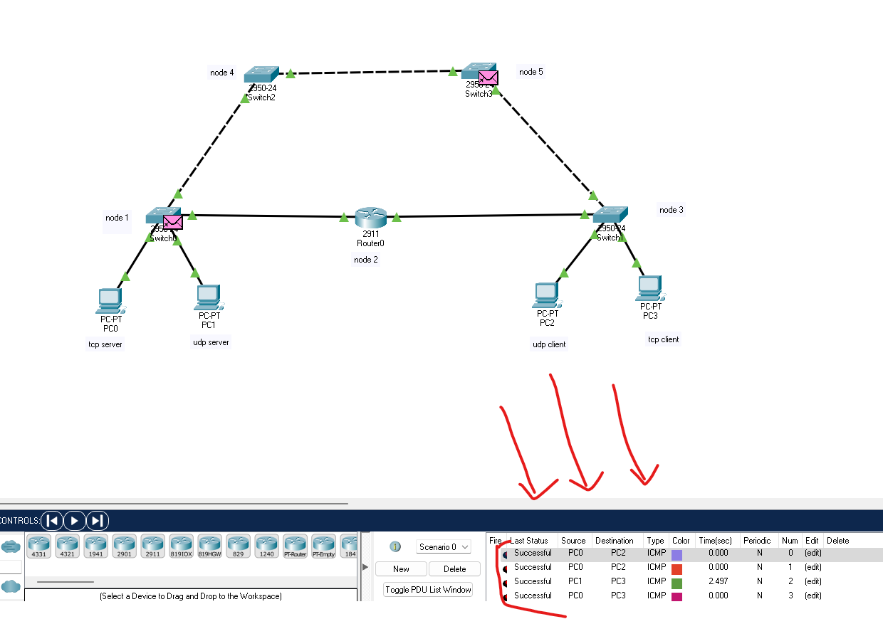

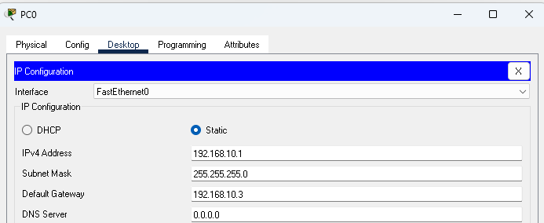

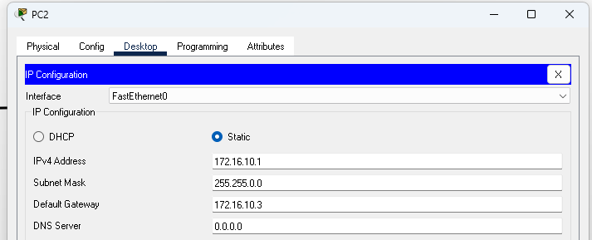

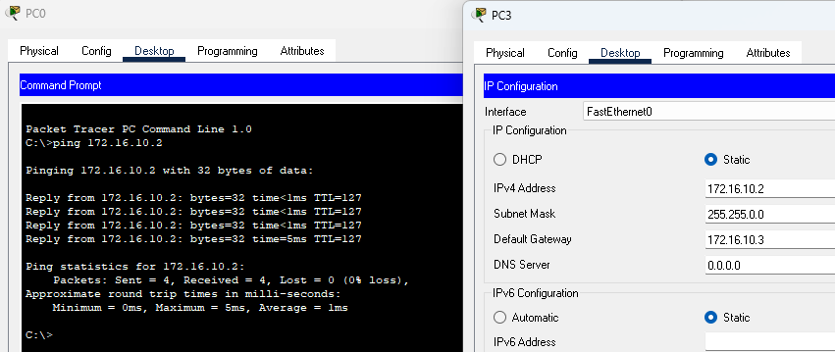

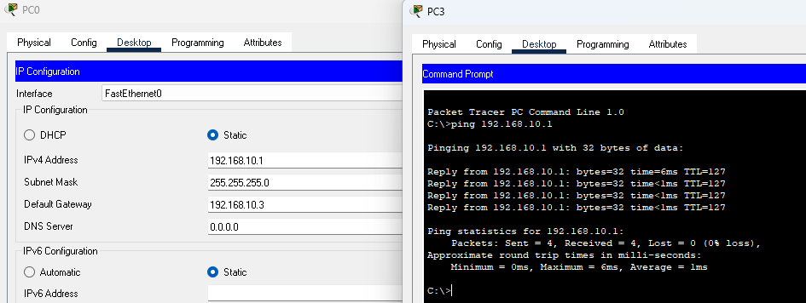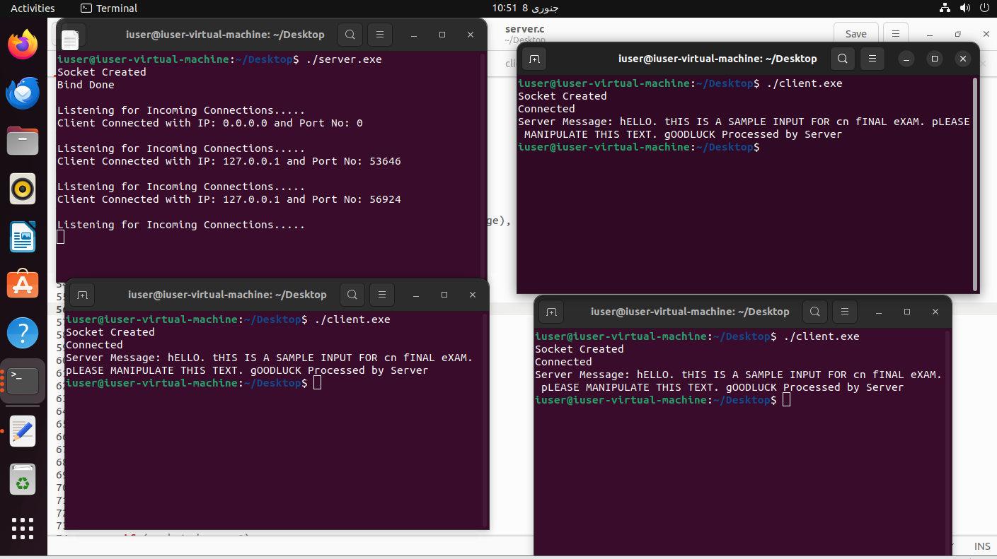

Server

#include <stdio.h>

#include <string.h>

#include <stdlib.h>

#include <pthread.h>

#include <unistd.h>

#include <sys/socket.h> //socket

#include <arpa/inet.h> //inet_addr

int clientcount = 0;

char server_message[2000], client_message[2000],client_message2[2000];

void *handleclients(void *socket_desc_ptr)

{

int socket_desc;

socket_desc = socket(AF_INET, SOCK_STREAM, 0);

int client_sock = *(int *)socket_desc_ptr;

recv(client_sock, client_message, sizeof(client_message), 0);

int j=0;

int index=0;

char servermsg[]="Processed by Server";

FILE* f;

f=fopen("output.txt","w");

for(int i=0;i<strlen(client_message);i++)

{

if(client_message[i]>='A' && client_message[i]<='Z')

{

client_message2[index]=client_message[i]+32;

index++;

}

else if(client_message[i]>='a' && client_message[i]<='z')

{

client_message2[index]=client_message[i]-32;

index++;

}else if(client_message[i]=='\n')

{

strcat(client_message2,servermsg);

}

else

{

client_message2[index]=client_message[i];

index++;

}

}

strcpy(server_message, client_message2);

fprintf(f, "%s", client_message2);

fflush(f);

if (send(client_sock, server_message, strlen(server_message), 0) < 0)

{

printf("Send Failed. Error!!!!!\n");

}

memset(server_message, '\0', sizeof(server_message));

memset(client_message, '\0', sizeof(client_message));

memset(client_message2, '\0', sizeof(client_message2));

clientcount--;

}

int main(void)

{

int socket_desc, client_sock, client_size;

struct sockaddr_in server_addr, client_addr;

pthread_t clients[5];

memset(server_message, '\0', sizeof(server_message));

memset(client_message, '\0', sizeof(client_message));

// Creating Socket

socket_desc = socket(AF_INET, SOCK_STREAM, 0);

if (socket_desc < 0)

{

printf("Could Not Create Socket. Error!!!!!\n");

return -1;

}

printf("Socket Created\n");

// Binding IP and Port to socket

server_addr.sin_family = AF_INET;

server_addr.sin_port = htons(2000);

server_addr.sin_addr.s_addr = inet_addr("127.0.0.1");

// BINDING FUNCTION

if (bind(socket_desc, (struct sockaddr *)&server_addr, sizeof(server_addr)) < 0)

{

printf("Bind Failed. Error!!!!!\n");

return -1;

}

printf("Bind Done\n");

// Put the socket into Listening State

if (listen(socket_desc, 1) < 0)

{

printf("Listening Failed. Error!!!!!\n");

return -1;

}

while (1)

{

if (clientcount <= 5)

{

printf("\nListening for Incoming Connections.....\n");

// Accept the incoming Connections

client_sock = accept(socket_desc, (struct sockaddr *)&client_addr, &client_size);

printf("Client Connected with IP: %s and Port No: %i\n", inet_ntoa(client_addr.sin_addr), ntohs(client_addr.sin_port));

pthread_create(&clients[clientcount], NULL, &handleclients, &client_sock);

clientcount++;

}

else

{

printf("\nPlease wait for other users to leave.");

sleep(20);

}

}

// Closing the Socket

close(client_sock);

close(socket_desc);

return 0;

}

Client

#include <stdio.h>

#include <string.h>

#include <string.h>

#include <stdlib.h>

#include <unistd.h>

#include <sys/socket.h> //socket

#include <arpa/inet.h> //inet_addr

int main(void)

{

int socket_desc;

struct sockaddr_in server_addr;

char server_message[2000], client_message[2000];

char filecontent[500];

socket_desc = socket(AF_INET, SOCK_STREAM, 0);

if (socket_desc < 0)

{

printf("Could Not Create Socket. Error!!!!!\n");

return -1;

}

printf("Socket Created\n");

server_addr.sin_family = AF_INET;

server_addr.sin_port = htons(2000);

server_addr.sin_addr.s_addr = inet_addr("127.0.0.1");

if (connect(socket_desc, (struct sockaddr *)&server_addr, sizeof(server_addr)) < 0)

{

printf("Connection Failed. Error!!!!!");

return -1;

}

printf("Connected\n");

FILE *f;

char temp[100];

f = fopen("input.txt", "r");

while (fgets(temp, sizeof(temp), f) != NULL)

{

strcat(filecontent, temp);

}

strcpy(client_message,filecontent);

// Send the message to Server

if (send(socket_desc, client_message, strlen(client_message), 0) < 0)

{

printf("Send Failed. Error!!!!\n");

return -1;

}

// Receive the message back from the server

if (recv(socket_desc, server_message, sizeof(server_message), 0) < 0)

{

printf("Receive Failed. Error!!!!!\n");

return -1;

}

printf("Server Message: %s\n", server_message);

memset(server_message, '\0', sizeof(server_message));

memset(client_message, '\0', sizeof(client_message));

// Closing the Socket

close(socket_desc);

return 0;

}